# Trends in Personal Loan Origination and Servicing

**AIM:** The "Trends in Personal Loan Origination and Servicing" dashboard aims to provide a comprehensive analysis of personal loan performance and trends. It focuses on annual percentage rates (APRs) for two-year bank loans across different credit ratings, total personal loan amounts over recent years, and monthly personal loan debt. This analysis helps financial institutions, policymakers, and researchers identify key patterns and trends, enabling data-driven decisions to improve lending strategies and borrower outcomes.

## FEATURES - Columns and Data Types Used

1. **Average Online Personal Loan Rates by Credit Score (Dec. 2022 - April 2024):**

* **Date:** Date of the recorded loan rate (Date type).
* **Excellent (720-850):** Average loan rate for excellent credit scores (Numeric type).
* **Good (690-719):** Average loan rate for good credit scores (Numeric type).
* **Fair (630-689):** Average loan rate for fair credit scores (Numeric type).
* **Bad (300-629):** Average loan rate for bad credit scores (Numeric type).

1. **Annual Percentage Rate for a Two-Year Bank Loan:**

* **Date:** Date of the recorded APR (Date type).
* **Rate (%):** Annual percentage rate for a two-year bank loan (Numeric type).

1. **Average Personal Loan Size:**

* **Date:** Date of the recorded loan size (Date type).
* **Loan Amount:** Average amount of personal loans (Numeric type).

1. **Monthly Personal Loan Debt (in billion $):**

* **Year:** Year of the recorded debt (Numeric type).
* **Month:** Month of the recorded debt (Categorical type).
* **Debt (in billion $):** Total personal loan debt recorded for that month (Numeric type).

## METHODOLOGY:

1. **Data Cleaning and Preparation:**

* Imported the dataset, including columns such as Average Online Personal Loan Rates by Credit Score, Annual Percentage Rate for a Two-Year Bank Loan, Average Personal Loan Size, and Monthly Personal Loan Debt.
* Cleaned the data by handling missing values, outliers, and ensuring consistency and accuracy.

1. **Analysis of Average Online Personal Loan Rates by Credit Score:**

* Created line charts tracking loan rates from Dec 2022 to Apr 2024 by credit score categories: Excellent, Good, Fair, and Bad.
* Analyzed trends to identify significant changes over the period.

1. **Analysis of Annual Percentage Rate for a Two-Year Bank Loan:**

* Created a line chart showing APR for a two-year bank loan from Feb 2019 onwards.
* Examined changes in APR over time.

1. **Analysis of Average Personal Loan Size:**

* Created a line chart tracking average personal loan size from Mar 2019 onwards.
* Analyzed trends in loan sizes.

1. **Monthly Personal Loan Debt Analysis:**

* Created bar charts showing monthly personal loan debt in billion dollars from Jan 2014.
* Analyzed changes in personal loan debt over time.

1. **Visualization and Dashboard Creation:**

* Compiled visualizations into a comprehensive, interactive dashboard.
* Included charts for average online personal loan rates by credit score, APR for a two-year bank loan, average personal loan size, and monthly personal loan debt.
* Enabled filtering by year and other relevant metrics.

## OUTPUT:

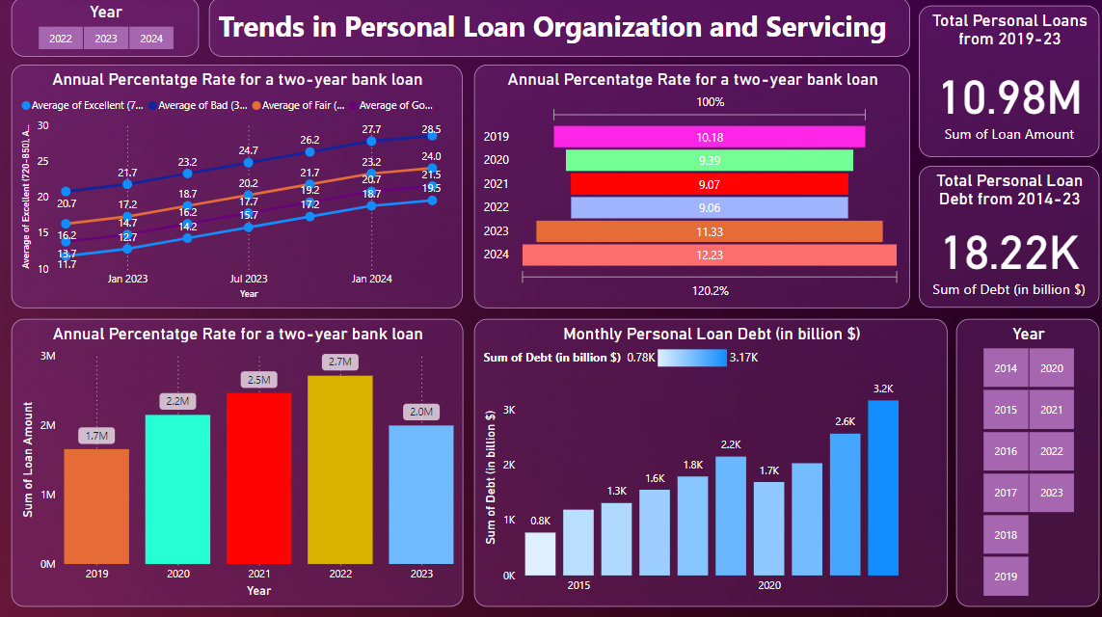

## RESULT ANALYSIS:

1. **Annual Percentage Rate for a Two-Year Bank Loan:**
   * The line chart shows APR trends over time for different credit ratings, highlighting how rates vary based on credit quality.
   * **Insight:** Borrowers with excellent credit consistently receive lower APRs, while those with bad credit see higher rates over time.
2. **Annual Percentage Rate Trends (2019-2024):**
   * The bar chart illustrates annual percentage rates for a two-year bank loan across different years.
   * **Insight:** There is a noticeable increase in APRs from 2019 to 2024, indicating changing lending conditions.
3. **Loan Amount Distribution (2019-2023):**
   * The bar chart shows the distribution of total loan amounts over recent years.
   * **Insight:** Loan amounts have varied, with a peak in 2022, suggesting fluctuations in lending activity.
4. **Monthly Personal Loan Debt (2014-2023):**
   * The column chart displays the sum of personal loan debt on a monthly basis.
   * **Insight:** Personal loan debt has been steadily increasing, with a significant rise in recent years.

## SUMMARY OF ANALYSIS:

The analysis reveals several important trends in personal loan origination and servicing. Borrowers with excellent credit scores benefit from lower APRs, while those with poorer credit face higher borrowing costs. Over the years, there has been a general increase in APRs, reflecting changes in the lending environment. Loan amounts have shown variability, with notable peaks indicating periods of higher lending activity. Personal loan debt has been on the rise, highlighting a growing reliance on personal loans. These insights can help lenders tailor their strategies to different borrower segments and adapt to evolving market conditions.